Please do the following settings on you word before beginning with each chapter. This will let the images have high resolution and avoid compression.

Step 1:

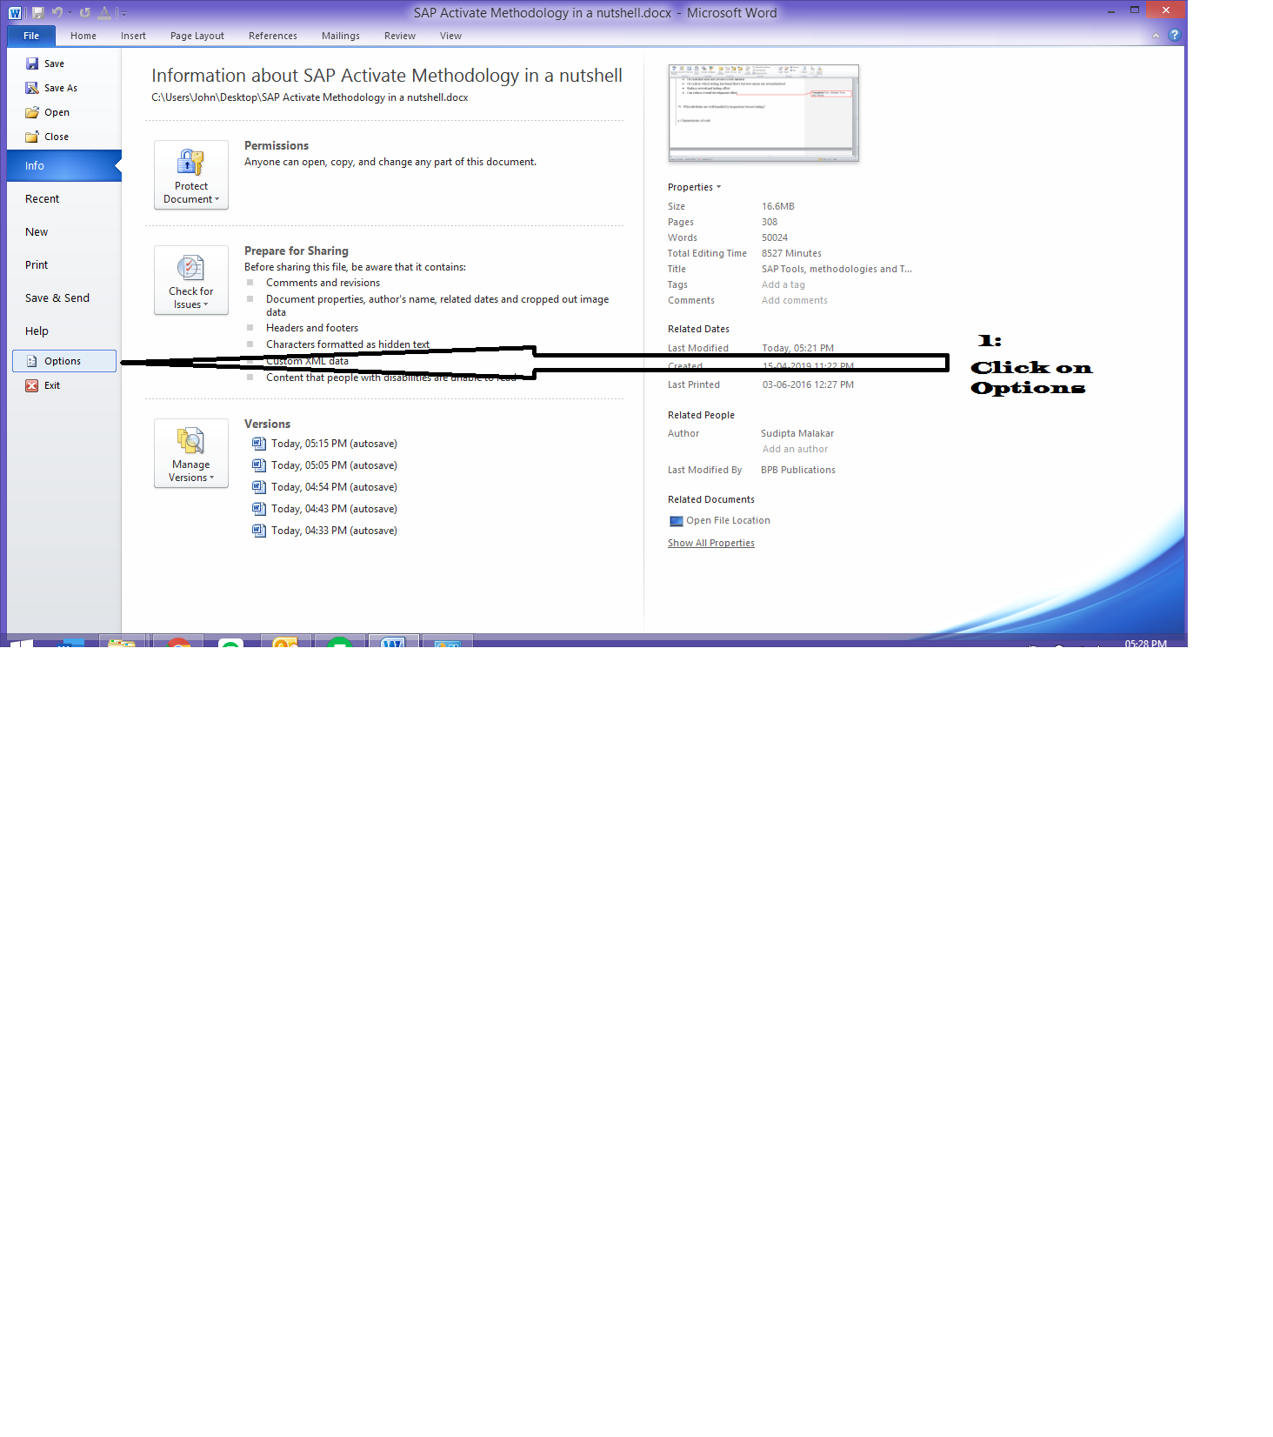

Step 2:

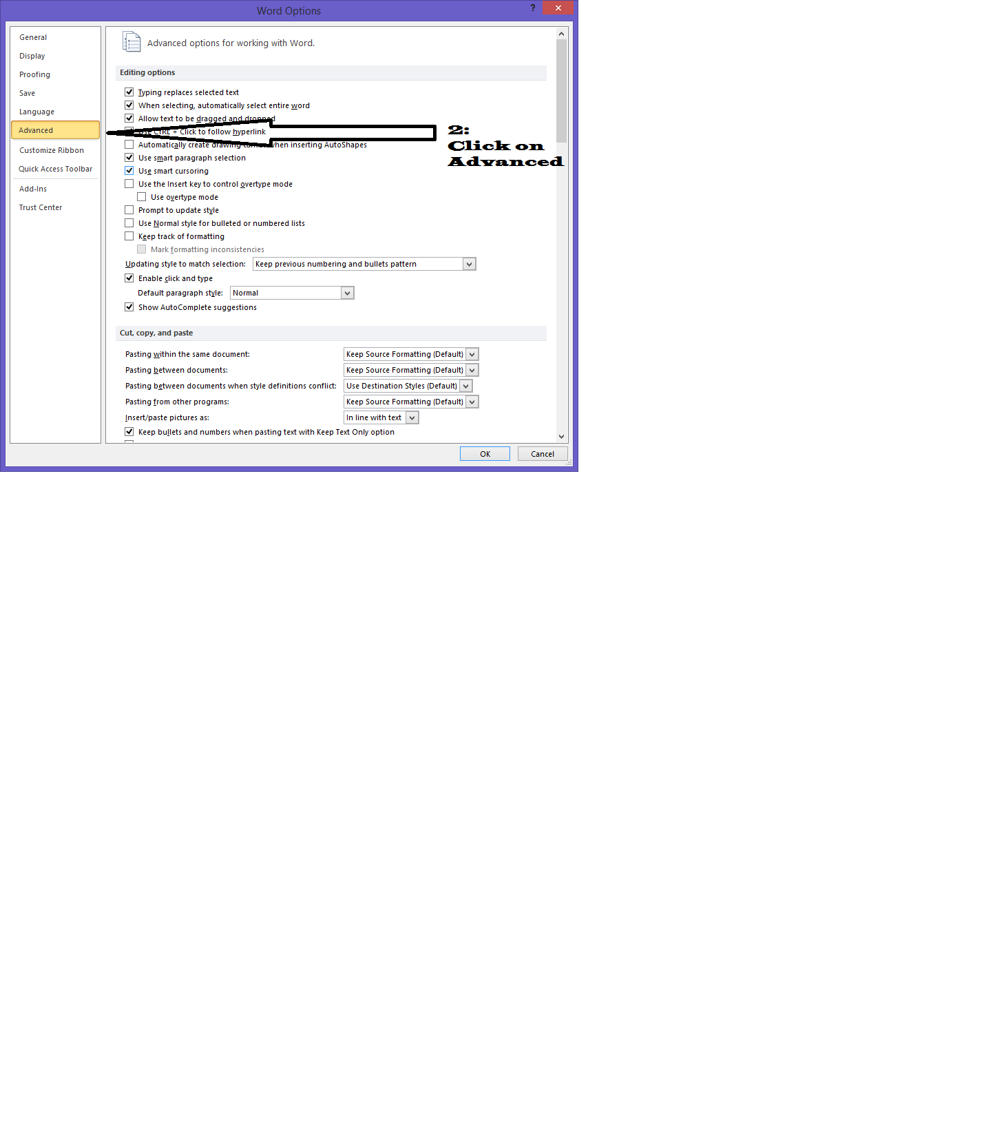

Step 3:

